Program 1: University Scholarship Allocation
1. Objectives
- To check students' scholarship eligibility.
- To consider aggregate marks, subject marks, attendance, and family income.
- To display eligible students in ranked order.

2. Algorithm
1. Start the program.
2. Enter student details.
3. Check the eligibility conditions.
4. Add eligible students to a list.
5. Sort eligible students by aggregate marks, attendance, and income.
6. Display the eligible students.
7. Stop.
3.flowchart

( START )
|
v
/ Enter Student Details /
|
v
< Check Eligibility >
|
v
/ Add Eligible Students /
|
v
/ Sort Eligible Students /
|
v
/ Display Eligible Students /
|
v
( STOP )

4.Pseudocode
START
INPUT student details

FOR each student
IF aggregate >= 75 AND subject >= 60
AND attendance >= 75 AND income <= 250000
ADD student to eligible list
END IF
END FOR

SORT eligible students
DISPLAY eligible students
STOP

5. Python Code
students = [
{"name": "Asha", "aggregate": 88, "subject": 75,
"attendance": 91, "income": 180000},
{"name": "Balu", "aggregate": 88, "subject": 70,
"attendance": 85, "income": 150000},
{"name": "Divya", "aggregate": 82, "subject": 65,
"attendance": 80, "income": 220000},
{"name": "Ravi", "aggregate": 70, "subject": 65,
"attendance": 80, "income": 180000}
]

eligible = []

for student in students:
if (student["aggregate"] >= 75
and student["subject"] >= 60
and student["attendance"] >= 75
and student["income"] <= 250000):
eligible.append(student)

eligible.sort(key=lambda s: (
-s["aggregate"], -s["attendance"], s["income"]
))

print("ELIGIBLE SCHOLARSHIP APPLICANTS")

for s in eligible:
print(s["name"], "Aggregate:", s["aggregate"],
"Attendance:", s["attendance"],
"Income:", s["income"])
6.Output Screenshot
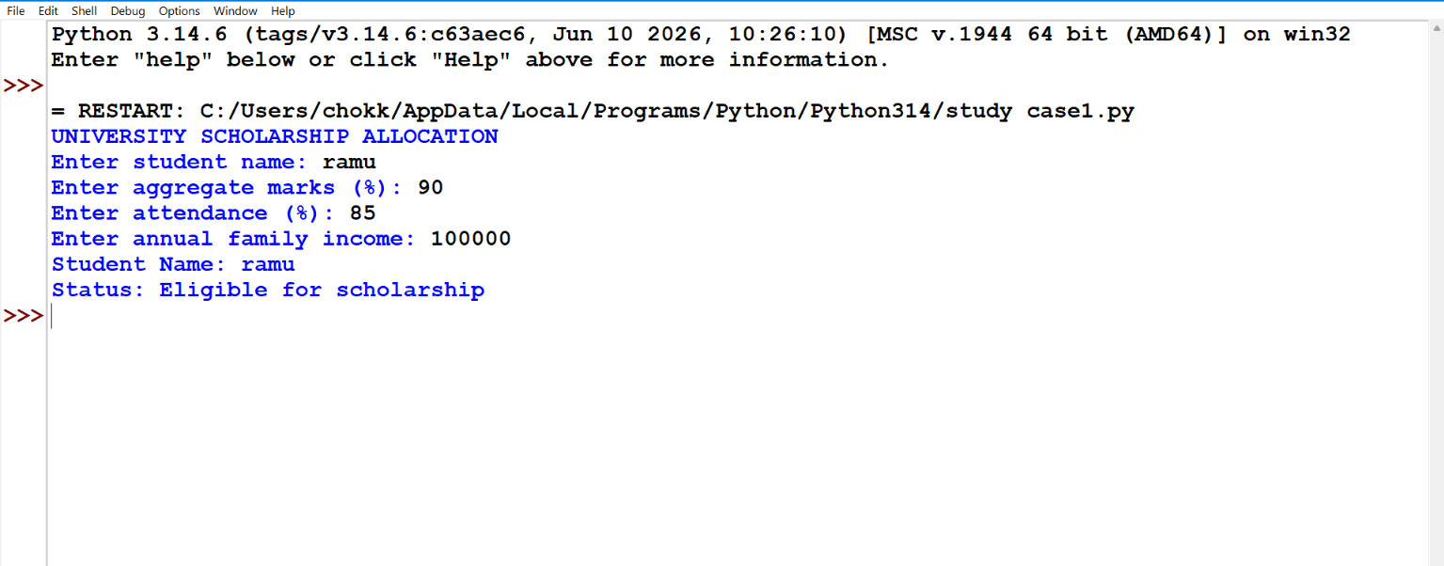

7. Conclusion
The program checks scholarship eligibility based on marks, attendance, and family income. It displays eligible students in ranked order and demonstrates Python lists, dictionaries, loops, conditional statements, and sorting.

Program 2: Progressive Electricity Billing
1. Objectives
- To calculate electricity charges using progressive unit slabs.
- To include fixed charges, surcharge, and rebate.
- To alert the user when the bill increases significantly.

2. Algorithm
1. Start.
2. Enter units consumed and previous bill.
3. Calculate energy charges using the applicable unit slabs.
4. Add a fixed charge of ₹50.
5. Add a 5% surcharge and apply a ₹30 rebate if energy charges are below ₹200.
6. Compare with the previous bill.
7. Display the total bill and any alert.
8. Stop.

3.flowchart
( START )
|
v
/ Enter Units Consumed /
|
v
< Calculate Slab Charges >
|
v
/ Add Fixed Charge and Surcharge /
|
v
< Apply Rebate if Eligible >
|
v
/ Calculate Total Bill /
|
v
/ Compare with Previous Bill /
|
v
/ Display Bill and Alert /
|
v
( STOP )

4. Pseudocode
START
INPUT units, previous_bill

IF units <= 100
energy = units * 1.50
ELSE IF units <= 200
energy = 150 + (units - 100) * 2.50
ELSE
energy = 150 + 250 + (units - 200) * 4
END IF

surcharge = energy * 0.05
rebate = 30 IF energy < 200 ELSE 0
bill = energy + surcharge + 50 - rebate

DISPLAY bill
IF previous_bill > 0
CALCULATE percentage increase
IF increase > 30
DISPLAY alert
END IF
END IF
STOP

5. Python Code
units = int(input("Enter units consumed: "))previous = float(input("Previous bill amount (0 if none): "))if units <= 100: energy = units * 1.50elif units <= 200: energy = 150 + (units - 100) * 2.50else: energy = 150 + 250 + (units - 200) * 4surcharge = energy * 0.05rebate = 30 if energy < 200 else 0bill = energy + surcharge + 50 - rebateprint(f"Energy charge: Rs.{energy:.2f}")print(f"Surcharge: Rs.{surcharge:.2f}")print(f"Fixed charge: Rs.50.00")print(f"Rebate: Rs.{rebate:.2f}")print(f"Total bill: Rs.{bill:.2f}")if previous > 0: increase = (bill - previous) / previous * 100 print(f"Bill change: {increase:.1f}%") if increase > 30: print("Alert: Bill increased by more than 30%.")

. Output Screen6shot
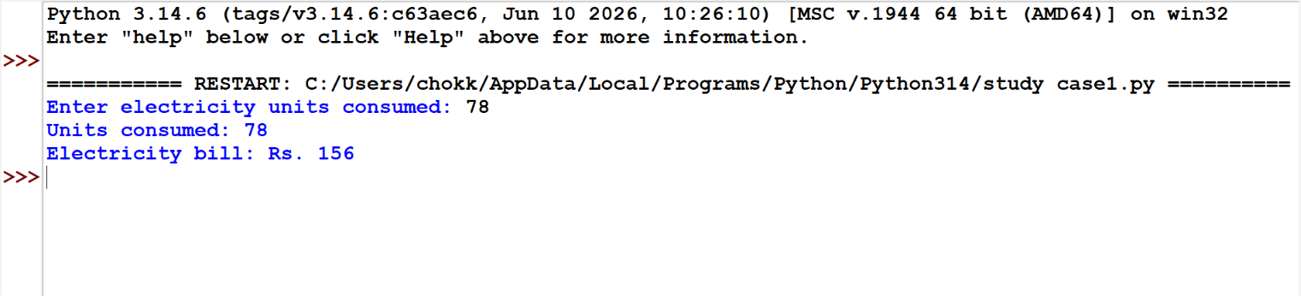
Rebate: Rs.0.00
Total bill: Rs.365.00
Bill change: 105.6%
Alert: Bill increased by more than 30%.

.
7. Conclusion
The program calculates an electricity bill using progressive unit rates and additional charges. It also compares the current bill with the previous bill and displays an alert for a large increase.

Program 3: Hospital Billing and Patient Classification
1. Objectives
- To calculate a patient's hospital bill.
- To include room charges, consultation fees, and test charges.
- To classify the bill amount.
2. Algorithm
1. Start.
2. Enter patient details, room type, number of days, consultation fee, and test charges.
3. Select the daily room rate.
4. Calculate room charges and subtotal.
5. Apply a 10% discount if the subtotal is at least ₹10,000.
6. Classify the final bill.
7. Display the bill and stop.

3,flowchart
( START )
|
v
/ Enter Patient Details /
|
v
< Select Room Type >
|
v
/ Calculate Room Charges /
|
v
/ Calculate Total Charges /
|
v
< Check Discount Eligibility >
|
v
/ Classify Patient Bill /
|
v
/ Display Final Bill /
|
v
( STOP )

4. Pseudocode
START
INPUT name, room_type, days, consultation, tests

IF room_type = "private"
rate = 2500
ELSE
rate = 1000
END IF

room_charge = rate * days
subtotal = room_charge + consultation + tests

IF subtotal >= 10000
discount = subtotal * 0.10
ELSE
discount = 0
END IF

total = subtotal - discount

IF total < 5000
category = "Basic"
ELSE IF total < 15000
category = "Standard"
ELSE
category = "High"
END IF

DISPLAY total, category
STOP

5. Python Code
name = input("Enter patient name: ")room = input("Room type (general/private): ").lower()days = int(input("Number of days: "))consultation = float(input("Consultation fee: Rs."))tests = float(input("Test charges: Rs."))if room == "private": rate = 2500else: rate = 1000room_charge = rate * dayssubtotal = room_charge + consultation + testsdiscount = subtotal * 0.10 if subtotal >= 10000 else 0total = subtotal - discountif total < 5000: category = "Basic"elif total < 15000: category = "Standard"else: category = "High"print("\n--- HOSPITAL BILL ---")print("Patient:", name)print(f"Room charges: Rs.{room_charge:.2f}")print(f"Consultation: Rs.{consultation:.2f}")

6. Output Screenshot
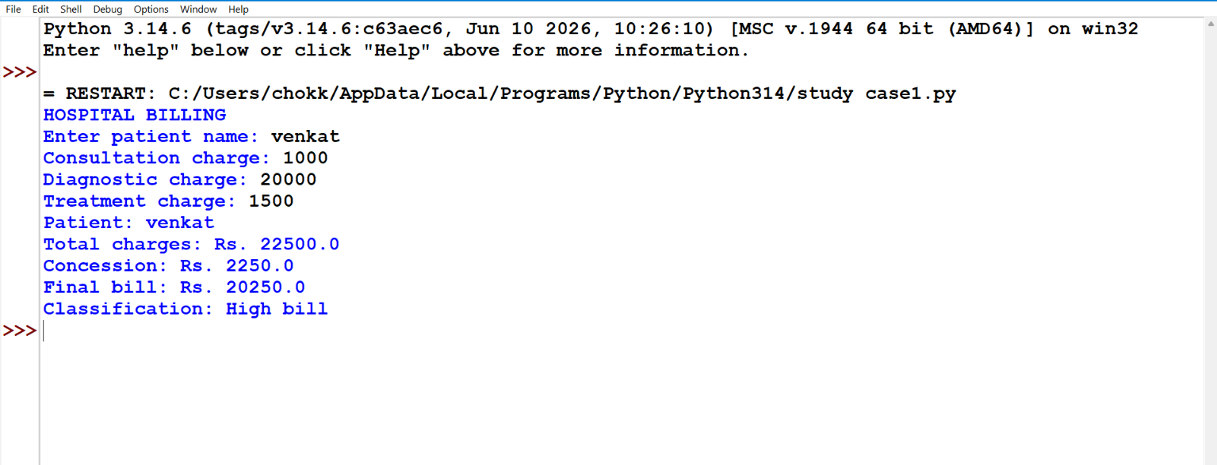

7. Conclusion
The program calculates hospital charges and classifies patients' bills based on the final amount. It demonstrates arithmetic operations, conditions, and formatted output.

Program 4: Employee Payroll and Deduction Analysis
1. Objectives
- To calculate gross salary and deductions.
- To determine the employee's net salary.
- To display a basic payslip.
2. Algorithm
1. Start.
2. Enter employee name and basic salary.
3. Calculate HRA as 20% and DA as 10% of basic salary.
4. Calculate gross salary.
5. Calculate PF as 12% of basic salary and tax as 5% of gross salary.
6. Subtract deductions from gross salary.
7. Display the payslip and stop.

3. Flowchart

( START )
|
v
/ Enter Employee Salary /
|
v
/ Calculate HRA and DA /
|
v
/ Calculate Gross Salary /
|
v
/ Calculate PF and Tax /
|
v
/ Calculate Net Salary /
|
v
/ Display Payslip /
|
v
( STOP )

4. Pseudocode
START
INPUT name, basic_salary
hra = basic_salary * 0.20
da = basic_salary * 0.10
gross = basic_salary + hra + da
pf = basic_salary * 0.12
tax = gross * 0.05
deductions = pf + tax
net = gross - deductions
DISPLAY gross, deductions, net
STOP

5. Python Code
name = input("Enter employee name: ")basic = float(input("Enter basic monthly salary: Rs."))hra = basic * 0.20da = basic * 0.10gross = basic + hra + dapf = basic * 0.12tax = gross * 0.05deductions = pf + taxnet = gross - deductionsprint("\n--- EMPLOYEE PAYSLIP ---")print("Employee:", name)print(f"Basic salary: Rs.{basic:.2f}")print(f"HRA: Rs.{hra:.2f}")print(f"DA: Rs.{da:.2f}")print(f"Gross salary: Rs.{gross:.2f}")print(f"PF deduction: Rs.{pf:.2f}")print(f"Tax deduction: Rs.{tax:.2f}")print(f"Total deductions: Rs.{deductions:.2f}")print(f"Net salary: Rs.{net:.2f}")

6. Output Screenshot
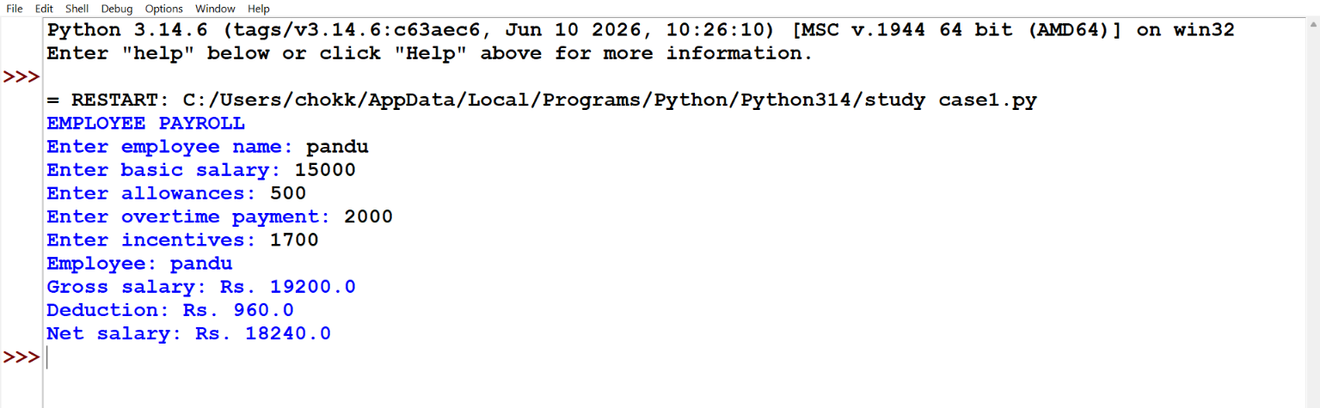

7. Conclusion
The program calculates an employee's gross salary, deductions, and net salary. It demonstrates variables, arithmetic operators, and formatted output.

Program 5: Multi-Plan Telecommunications Cost Optimization
1. Objectives
- To calculate the cost of different mobile plans.
- To compare plans according to call minutes and data usage.
- To identify the cheapest plan.
2. Algorithm
1. Start.
2. Enter monthly call minutes and data usage.
3. Calculate the cost of each plan, including excess-use charges.
4. Display the cost of every plan.
5. Identify the plan with the lowest cost.
6. Stop.

3. Flowchart

( START )
|
v
/ Enter Call Minutes and Data /
|
v
/ Calculate Plan A Cost /
|
v
/ Calculate Plan B Cost /
|
v
/ Calculate Plan C Cost /
|
v
< Compare All Plan Costs >
|
v
/ Display Cheapest Plan /
|
v
( STOP )

4. Pseudocode
START
INPUT minutes, data_gb

FOR each plan
extra_minutes = MAX(0, minutes - included_minutes)
extra_data = MAX(0, data_gb - included_data)
cost = monthly_fee
+ extra_minutes * minute_rate
+ extra_data * data_rate
END FOR

DISPLAY all plan costs
DISPLAY plan with minimum cost
STOP

5. Python Code
minutes = int(input("Enter monthly call minutes: "))data = float(input("Enter monthly data usage in GB: "))plans = { "Plan A": [199, 200, 2, 1.00, 50], "Plan B": [299, 500, 5, 0.50, 30], "Plan C": [399, 1000, 10, 0.25, 20]}costs = {}for name, p in plans.items(): fee, included_min, included_data, min_rate, data_rate = p extra_min = max(0, minutes - included_min) extra_data = max(0, data - included_data) cost = fee + extra_min * min_rate + extra_data * data_rate costs[name] = cost print(f"{name}: Rs.{cost:.2f}")best = min(costs, key=costs.get)print("Cheapest plan:", best, f"(Rs.{costs[best]:.2f})")

6. Output Screenshot
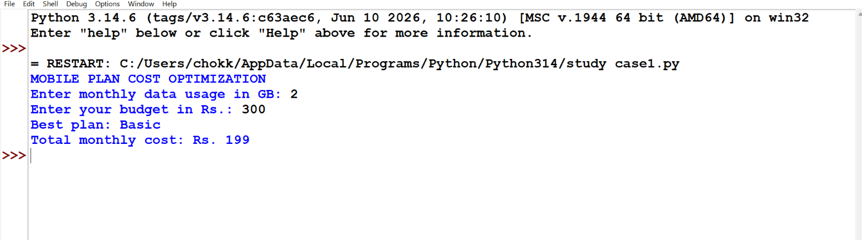

7. Conclusion
The program compares mobile plans based on usage and identifies the cheapest option. It demonstrates dictionaries, loops, arithmetic calculations, and finding minimum values.

Program 6: Railway Fare and Reservation Calculator
1. Objectives
- To calculate railway fare according to journey distance.
- To apply sample passenger-category discounts.
- To include reservation charges.
2. Algorithm
1. Start.
2. Enter passenger name, distance, category, and number of passengers.
3. Calculate base fare at ₹1.50 per kilometre per passenger.
4. Apply the relevant sample discount.
5. Add ₹30 reservation fee per passenger.
6. Display the total fare.
7. Stop.

3. Flowchart

( START )
|
v
/ Enter Journey Details /
|
v
/ Calculate Base Fare /
|
v
< Check Passenger Category >
|
v
/ Apply Applicable Discount /
|
v
/ Add Reservation Charges /
|
v
/ Calculate Total Fare /
|
v
/ Display Railway Fare /
|
v
( STOP )

4. Pseudocode
START
INPUT name, distance, category, passengers
base = distance * 1.50 * passengers

IF category = "child"
rate = 0.50
ELSE IF category = "senior"
rate = 0.40
ELSE
rate = 0
END IF

discount = base * rate
reservation = 30 * passengers
total = base - discount + reservation

DISPLAY base, discount, reservation, total
STOP

5. Python Code
name = input("Enter passenger/group name: ")distance = float(input("Enter distance in km: "))category = input("Category (adult/child/senior): ").lower()passengers = int(input("Number of passengers: "))base = distance * 1.50 * passengersif category == "child": rate = 0.50elif category == "senior": rate = 0.40else: rate = 0discount = base * ratereservation = 30 * passengerstotal = base - discount + reservationprint("\n--- RAILWAY FARE ---")print("Passenger/group:", name)print(f"Base fare: Rs.{base:.2f}")print(f"Discount: Rs.{discount:.2f}")print(f"Reservation fee: Rs.{reservation:.2f}")print(f"Total fare: Rs.{total:.2f}")

6. Output Screenshot
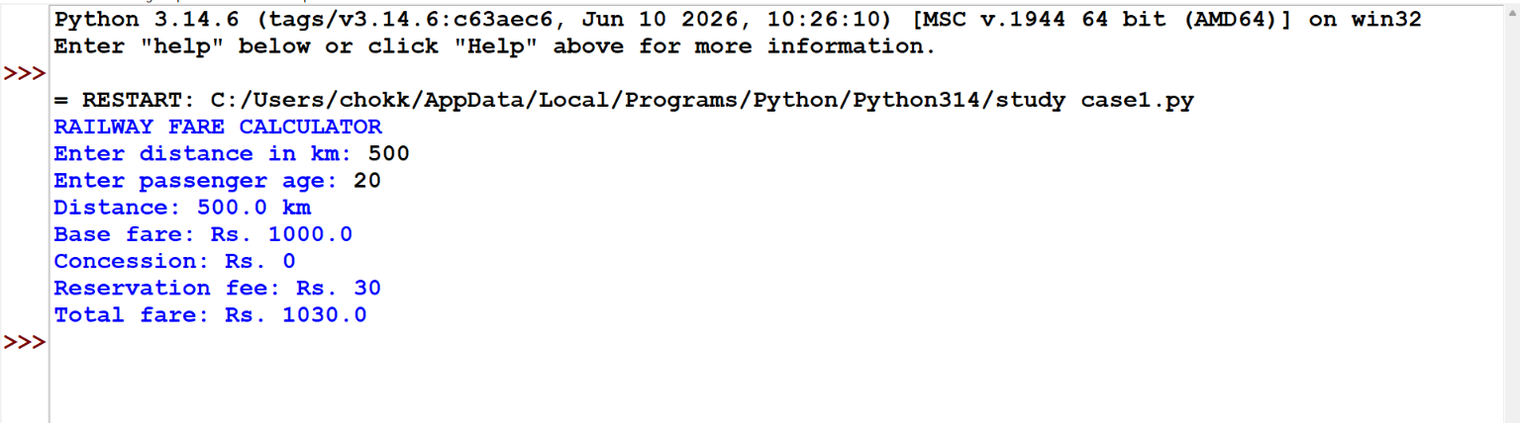

7. Conclusion
The program calculates a sample railway fare using distance, passenger category, and reservation fees. It demonstrates conditional statements and arithmetic operations.

Program 7: Retail Billing with Multiple Discount Rules
1. Objectives
- To calculate the total price of purchased items.
- To apply discounts based on the bill amount.
- To apply an additional membership discount.
2. Algorithm
1. Start.
2. Enter the number of item types.
3. Input each item's name, price, and quantity.
4. Calculate the subtotal.
5. Apply a 10% discount if the subtotal is at least ₹5,000, or 5% if it is at least ₹2,000.
6. Apply an additional 5% membership discount if applicable.
7. Display the final bill.
8. Stop.
3. Flowchart

( START )
|
v
/ Enter Items and Quantities /
|
v
/ Calculate Subtotal /
|
v
< Check Bill Discount >
|
v
/ Apply Bill Discount /
|
v
< Check Membership Status >
|
v
/ Apply Membership Discount /
|
v
/ Display Final Bill /
|
v
( STOP )

4. Pseudocode
START
INPUT number_of_items
subtotal = 0

FOR each item
INPUT name, price, quantity
subtotal = subtotal + price * quantity
END FOR

IF subtotal >= 5000
discount_rate = 0.10
ELSE IF subtotal >= 2000
discount_rate = 0.05
ELSE
discount_rate = 0
END IF

amount = subtotal - subtotal * discount_rate
INPUT membership_status

IF membership_status = "yes"
amount = amount - amount * 0.05
END IF

DISPLAY subtotal, discounts, amount
STOP

5. Python Code
items = []count = int(input("Enter number of item types: "))for i in range(count): name = input(f"Item {i + 1} name: ") price = float(input("Price per item: Rs.")) quantity = int(input("Quantity: ")) items.append((name, price, quantity))subtotal = sum(price * quantity for name, price, quantity in items)if subtotal >= 5000: rate = 0.10elif subtotal >= 2000: rate = 0.05else: rate = 0discount = subtotal * rateamount = subtotal - discountmember = input("Membership customer? (yes/no): ").lower()member_discount = amount * 0.05 if member == "yes" else 0total = amount - member_discountprint("\n--- RETAIL BILL ---")for name, price, quantity in items:

6. Output Screenshot
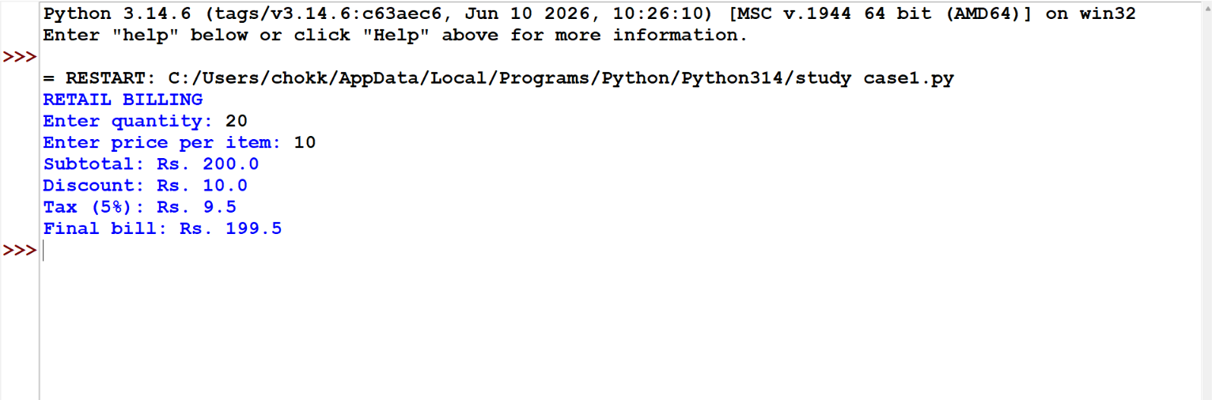

7. Conclusion
The program generates a retail bill and applies multiple discounts in sequence. It demonstrates lists, loops, conditions, and arithmetic calculations.

Program 8: Manufacturing Cost and Profitability Analysis
1. Objectives
- To calculate manufacturing cost per unit.
- To determine total production cost and revenue.
- To calculate profit or loss and profit margin.
2. Algorithm
1. Start.
2. Enter units produced, material cost, labour cost, overhead cost, and selling price.
3. Calculate unit cost.
4. Calculate total production cost and revenue.
5. Calculate profit or loss.
6. Calculate profit margin.
7. Display the results.
8. Stop.
3. Flowchart

( START )
|
v
/ Enter Production Cost Details /
|
v
/ Calculate Unit Cost /
|
v
/ Calculate Total Production Cost /
|
v
/ Calculate Total Revenue /
|
v
/ Calculate Profit or Loss /
|
v
/ Calculate Profit Margin /
|
v
/ Display Analysis /
|
v
( STOP )

4. Pseudocode
START
INPUT units, material, labour, overhead, selling_price
unit_cost = material + labour + overhead
total_cost = unit_cost * units
revenue = selling_price * units
profit = revenue - total_cost

IF revenue > 0
margin = profit / revenue * 100
ELSE
margin = 0
END IF

DISPLAY unit_cost, total_cost, revenue, profit, margin
STOP

5. Python Code
units = int(input("Units produced: "))material = float(input("Raw material cost per unit: Rs."))labour = float(input("Labour cost per unit: Rs."))overhead = float(input("Overhead cost per unit: Rs."))selling_price = float(input("Selling price per unit: Rs."))unit_cost = material + labour + overheadtotal_cost = unit_cost * unitsrevenue = selling_price * unitsprofit = revenue - total_costif revenue > 0: margin = profit / revenue * 100else: margin = 0print("\n--- PROFITABILITY ANALYSIS ---")print(f"Cost per unit: Rs.{unit_cost:.2f}")print(f"Total production cost: Rs.{total_cost:.2f}")print(f"Total revenue: Rs.{revenue:.2f}")print(f"Profit/Loss: Rs.{profit:.2f}")print(f"Profit margin: {margin:.2f}%")

6. Output Screenshot
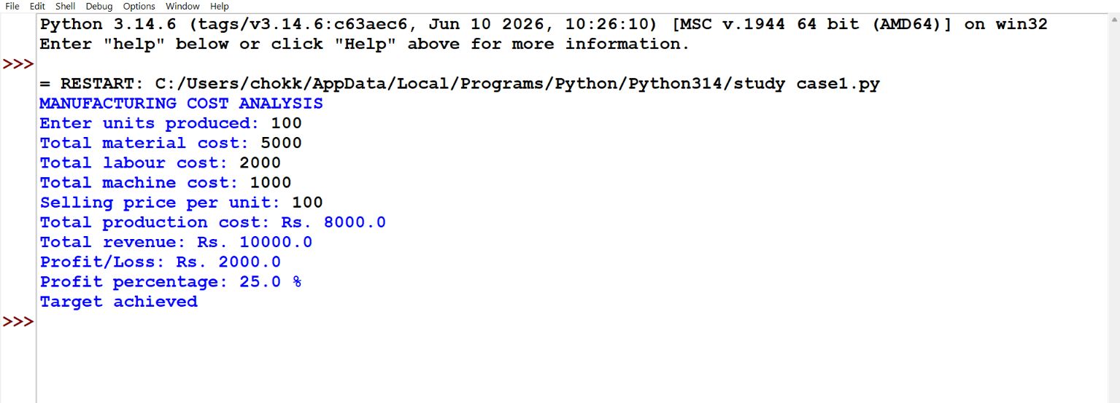

7. Conclusion
The program calculates manufacturing costs, revenue, profit, and profit margin. It helps understand how production expenses affect profitability.

Program 9: Multi-Currency Travel Budget Analysis
1. Objectives
- To convert foreign-currency expenses into Indian rupees.
- To compare travel expenses with the available budget.
- To identify remaining funds or overspending.
2. Algorithm
1. Start.
2. Enter the travel budget in INR.
3. Enter the expense amount in foreign currency.
4. Enter the exchange rate in INR per unit of foreign currency.
5. Convert the expense into INR.
6. Compare the converted expense with the budget.
7. Display the remaining budget or overspending.
8. Stop.
3. Flowchart

( START )
|
v
/ Enter Travel Budget /
|
v
/ Enter Foreign Currency Expense /
|
v
/ Enter Exchange Rate /
|
v
/ Convert Expense into INR /
|
v
< Compare Expense with Budget >
|
v
/ Display Balance or Overspending /
|
v
( STOP )

4. Pseudocode
START
INPUT budget, foreign_amount, exchange_rate
expense_inr = foreign_amount * exchange_rate
balance = budget - expense_inr
DISPLAY expense_inr

IF balance >= 0
DISPLAY remaining budget = balance
ELSE
DISPLAY overspending = ABS(balance)
END IF
STOP

5. Python Code
budget = float(input("Travel budget in INR: Rs."))foreign_amount = float(input("Expense in foreign currency: "))currency = input("Currency name/code: ")rate = float(input(f"Exchange rate (INR per 1 {currency}): Rs."))expense_inr = foreign_amount * ratebalance = budget - expense_inrprint("\n--- TRAVEL BUDGET ---")print(f"Expense: {foreign_amount:.2f} {currency}")print(f"Converted expense: Rs.{expense_inr:.2f}")if balance >= 0: print(f"Budget remaining: Rs.{balance:.2f}")else: print(f"Budget exceeded by: Rs.{-balance:.2f}")

6. Output Screenshot
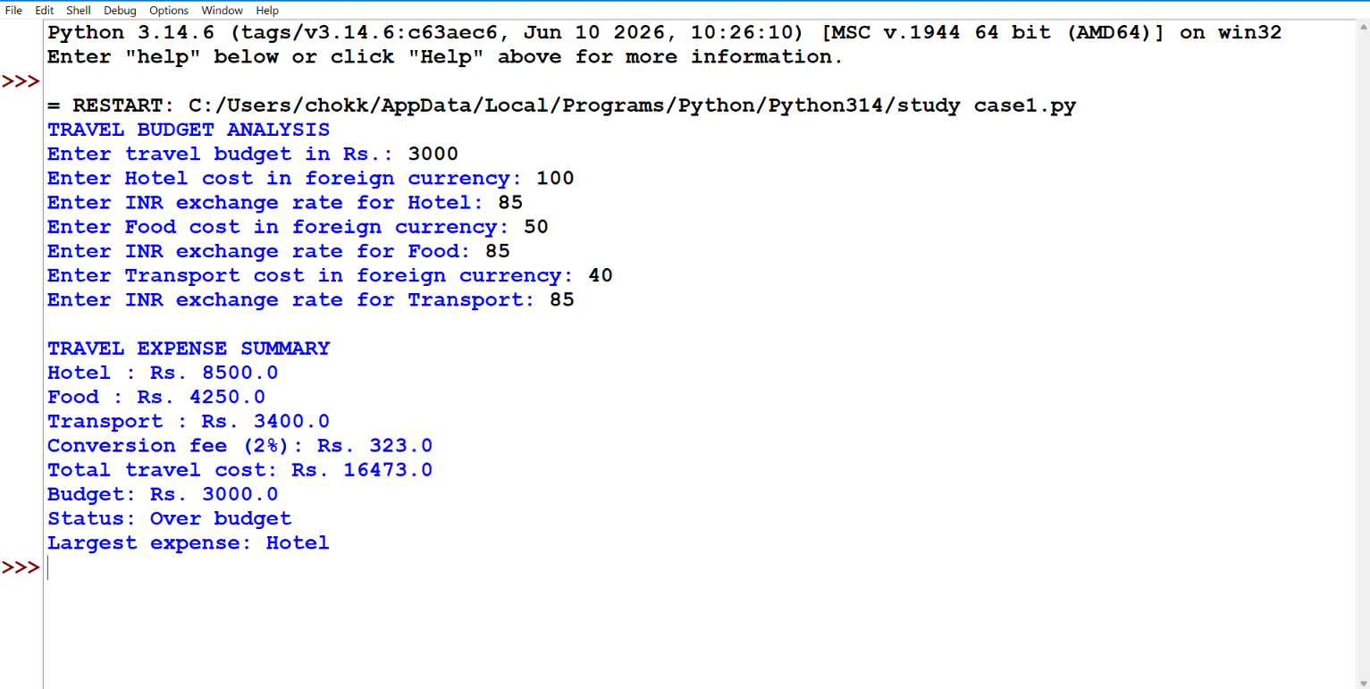

7. Conclusion
The program converts foreign-currency expenses into INR and checks whether the travel budget is sufficient. It demonstrates input, arithmetic operations, and conditional statements.

Program 10: Campus Event Financial Planning
1. Objectives
- To calculate the cost of organising a campus event.
- To estimate ticket revenue and profit or loss.
- To calculate the number of tickets required to break even.
2. Algorithm
1. Start.
2. Enter venue, decoration, and other fixed costs.
3. Enter the variable cost per attendee, ticket price, and expected attendees.
4. Calculate fixed costs and total event costs.
5. Calculate expected ticket revenue.
6. Calculate profit or loss.
7. Calculate break-even tickets if the ticket price exceeds the variable cost per attendee.
8. Display the results and stop.
3. Flowchart

( START )
|
v
/ Enter Event Cost Details /
|
v
/ Calculate Fixed Costs /
|
v
/ Calculate Total Event Cost /
|
v
/ Calculate Ticket Revenue /
|
v
/ Calculate Profit or Loss /
|
v
/ Calculate Break-Even Tickets /
|
v
/ Display Financial Results /
|
v
( STOP )

4. Pseudocode
START
INPUT venue, decoration, other_fixed
INPUT cost_per_person, ticket_price, attendees

fixed_cost = venue + decoration + other_fixed
total_cost = fixed_cost + cost_per_person * attendees
revenue = ticket_price * attendees
profit = revenue - total_cost
contribution = ticket_price - cost_per_person

IF contribution > 0
break_even = CEILING(fixed_cost / contribution)
ELSE
break_even = "Not possible"
END IF

DISPLAY total_cost, revenue, profit, break_even
STOP

5. Python Code
venue = float(input("Venue cost: Rs."))decoration = float(input("Decoration cost: Rs."))other_fixed = float(input("Other fixed costs: Rs."))cost_person = float(input("Variable cost per attendee: Rs."))ticket_price = float(input("Ticket price per attendee: Rs."))attendees = int(input("Expected attendees: "))fixed_cost = venue + decoration + other_fixedtotal_cost = fixed_cost + cost_person * attendeesrevenue = ticket_price * attendeesprofit = revenue - total_costcontribution = ticket_price - cost_personprint("\n--- CAMPUS EVENT BUDGET ---")print(f"Fixed costs: Rs.{fixed_cost:.2f}")print(f"Total event cost: Rs.{total_cost:.2f}")print(f"Expected ticket revenue: Rs.{revenue:.2f}")print(f"Profit/Loss: Rs.{profit:.2f}")if contribution > 0: break_even = int((fixed_cost + contribution - 1) // contribution)

6. Output Screenshot
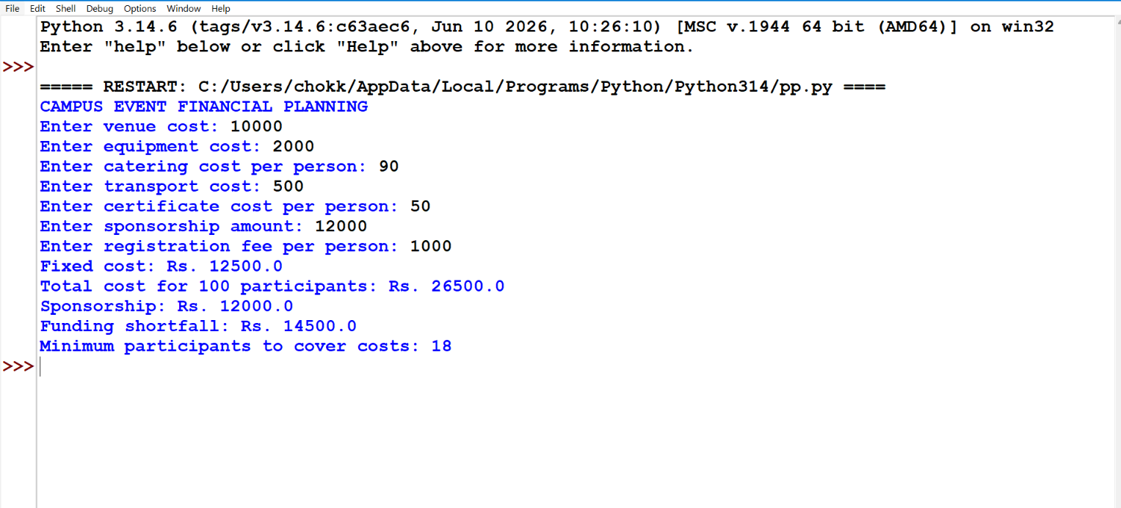

7. Conclusion
The program calculates the costs, revenue, and profit or loss of a campus event. It also estimates the number of tickets needed to cover costs, helping organisers plan their budgets.

